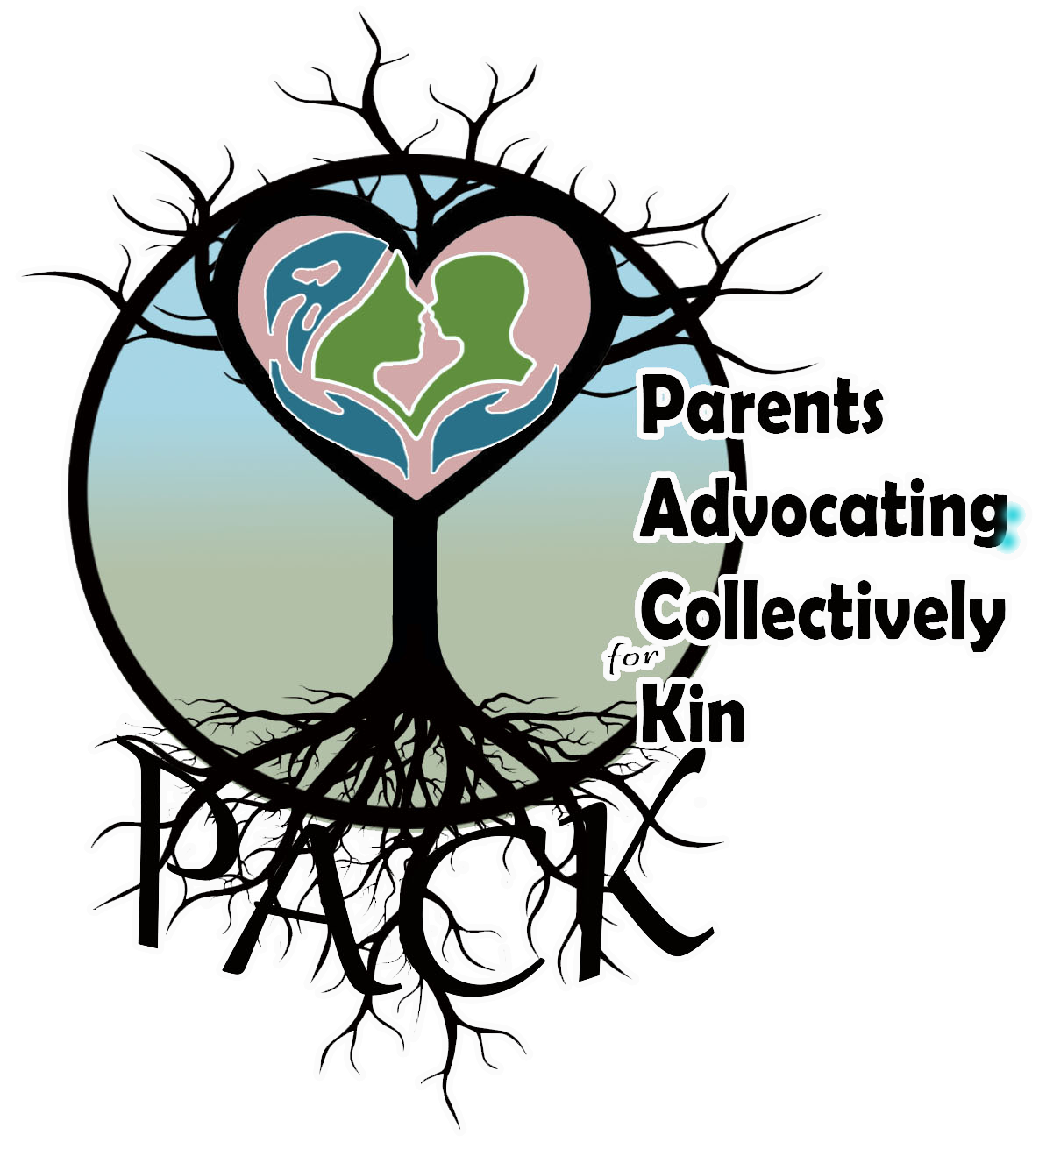
PACK Substance Use Safety Plan
Child/Children
Name(s): _____________________
Birth date(s): __________________
This Document is a commitment between loving family members that supports loving intentions oooooooo
My circle of support
People I know and trust who can take care of my child(ren) if I feel the need to use substances:
- _______________________________ Phone #: ___________
- _______________________________ Phone #: ___________
- _______________________________ Phone #: ___________
People I know and trust who I can turn to if I need support or a break:
- _______________________________ Phone #: ___________
- _______________________________ Phone #: ___________
- _______________________________ Phone #: ___________

Safety for my child and me
The risk of overdose increases for people who have not used substances for a while. Keeping my child safe means keeping me safe - we both matter. To be safe while using I plan to- (circle all the apply)
Use with others who have Narcan kits / Connect with a peer / Use smaller amounts / Use an app (NORS, Lifeguard) / Use distance witnessing (call a peer who knows your location and can stay in contact)

