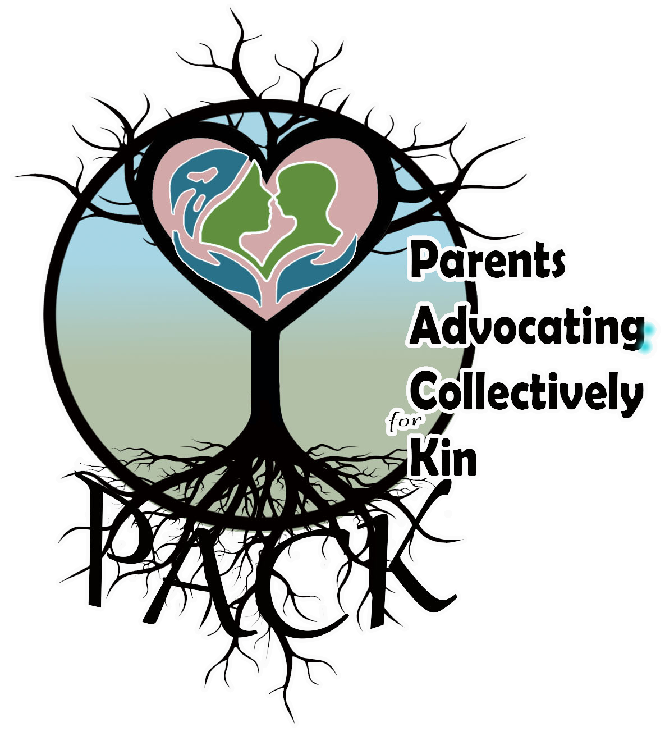
PACK Substance Use Safety Plan
-Newborn/Infant
Welcome to the world little one-
Name: _____________________
Birth date: __________________
This Document is a commitment between parent and child that supports loving intentions to ensure safety and success
My circle of support
People I know and trust who can take care of my child if I feel the need to use substances:
- _______________________________ Phone #: ___________
- _______________________________ Phone #: ___________
- _______________________________ Phone #: ___________
People I know and trust who I can turn to if I need support or a break:
- _______________________________ Phone #: ___________
- _______________________________ Phone #: ___________
- _______________________________ Phone #: ___________
Safety for my child and me
I recognize that breast/chest feeding is not safe after I use- for 24 hours. If I use, I plan to-
__ Use my milk pumped before I use (pre-frozen, or pumped right before substance use)
__ Use donated breast milk (if available)
__ Use iron-fortified formula
The risk of overdose increases for people who have not used substances for a while. Keeping my child safe means keeping me safe - we both matter. To be safe while using I plan to- (circle all the apply)
Use with others who have Narcan kits / Connect with a peer / Use smaller amounts / Use an app (NORS, Lifeguard) / Use distance witnessing (call a peer who knows your location and can stay in contact)

